# OOP A

## Question 1: (Palace of Atom)

Palace of Atom, also known as "Wang Dong Programmer", this elegant place is full of knowledge of Various programming The palace is located at Phitsanulok - Nakhon Sawan 99 Moo 9, Tha Pho Subdistrict Tha Pho, Mueang Phitsanulok District, 65000 The key is that this palace has been stung by programmers as Provide the best programming knowledge

Write a class named Palace with fields for "castle" and "principality".

* getCastle returns the number of castles
* getPrincipality returns the number of principality

Template:

public static void main(String[] args)

{

Scanner sc = new Scanner(System.in);

Palace p = new Palace(sc.nextInt(), sc.nextInt());

System.out.print("Palace of Atom has "+p.getCastle()+ " Castle");

if(p.getCastle()>1)

{

System.out.print("s");

}

System.out.print(" including "+p.getPrincipality()+" Principality");

if(p.getPrincipality()>1)

{

System.out.print("s");

}

}

Input Output

1 Palace of Atom has 1 Castle including 1 Principality

1

3 Palace of Atom has 3 Castles including 5 Principalitys

5

### Captureโค้ด Class Palace และ ผลการรัน

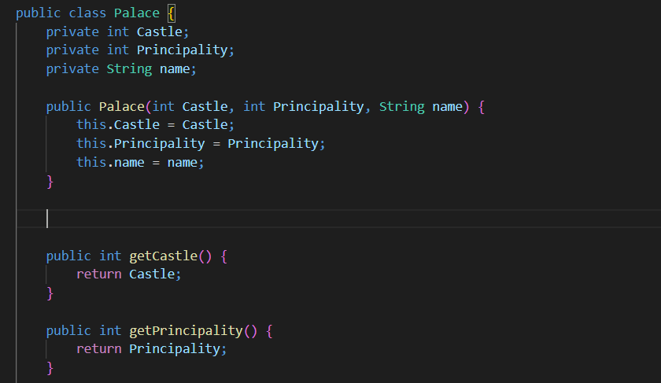

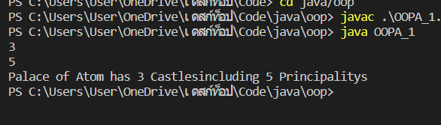

Question 2: (Add toString() method)

Add a new method to the Palace named toString that returns amount of the castle and principality

Template:

public static void main(String[] args)

{

Scanner sc = new Scanner(System.in);

int castle = Integer.parseInt(sc.nextLine());

int principality = Integer.parseInt(sc.nextLine());

Palace p = new Palace(castle,principality);

System.out.println(p.toString());

}

Input

1

1

Output

Palace of Atom has The sum of the castle and principality amount 2

Input

2

4

Output

Palace of Atom has The sum of the castle and principality amount 6

### Capture โค้ด Method toString() และ ผลการรัน

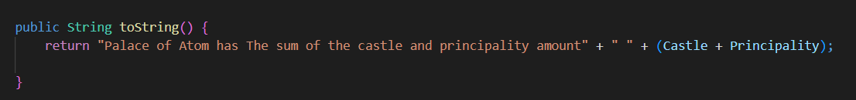

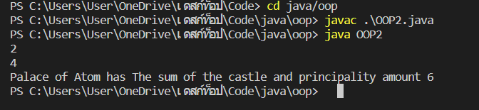

Question 3: (Is it a Large Palace)

A Large Palace is a with if the castle more than 5 and principality 8 . Add a method named is LargePalace that returns true if the Palace is Large Palace

public static void main(String[] args)

{

Scanner sc = new Scanner(System.in);

int castle = Integer.parseInt(sc.nextLine());

int principality = Integer.parseInt(sc.nextLine());

String name = sc.nextLine();

Palace p = new Palace(castle,principality,name);

if (p.LargePalace()==true)

{

System.out.println(p.getName()+" is a Large Palace");

}

else

{

System.out.println(p.getName()+" is a Normal Palace");

}

}

Input Output

8 Palace Atom is a Large Palace

10

Input Output

7 Palace Versailles is a Large Palace

12

Versailles

Input Output

5 Palace Alhambra is a Normal Palace

7

Alhambra

### Capture โค้ด Method is it a Large Palace() และ ผลการรัน

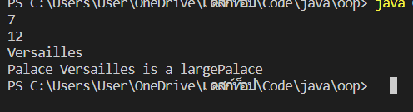

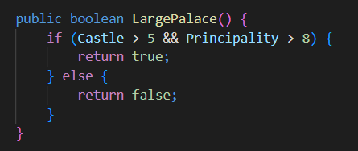

Question 4: (Is it a Large Palace)

Castles have owner. Add a method named is IsyouCastle that returns true if the correct name Castle owner (มี 5 เงื่อนไขน่ะ)

* Vachirapon Tosawat owns the java
* Natchanon Pongrattananukul owns the the python
* Nanthaphong Khongyut owns the the kotlin
* Thadaphong Kesornprom owns the the swift
* Puwanasul Klanhun owns the ruby

public static void main(String[] args)

{

Scanner sc = new Scanner(System.in);

int castle = Integer.parseInt(sc.nextLine());

int principality = Integer.parseInt(sc.nextLine());

String owner = sc.nextLine().toLowerCase();

String name = sc.nextLine().toLowerCase();

Palace p = new Palace(castle,principality,name,owner);

if (p.isyourCastle()==true)

{

System.out.println(p.getOwner()+" is the owner of the "+p.getName()+" castle.");

}

else

{

System.out.println(p.getOwner()+" isn't the owner of the "+p.getName()+" castle.");

}

}

Input

8

10

Vachirapon Tosawat

java

Output

Vachirapon Tosawat is the owner of the java castle.

Input

12

15

Natchanon Pongrattananukul

python

Output

Natchanon Pongrattananukul is the owner of the python castle.

Input

9

12

Nanthaphong Khongyut

ruby

Output

Nanthaphong Khongyut isn't the owner of the ruby castle.

### Capture โค้ด Method Is it a Large Palace() และ ผลการรัน

